1. All the information from packages and admins with at least 1 package and id > 10, only 30 rows, 5 cut off.

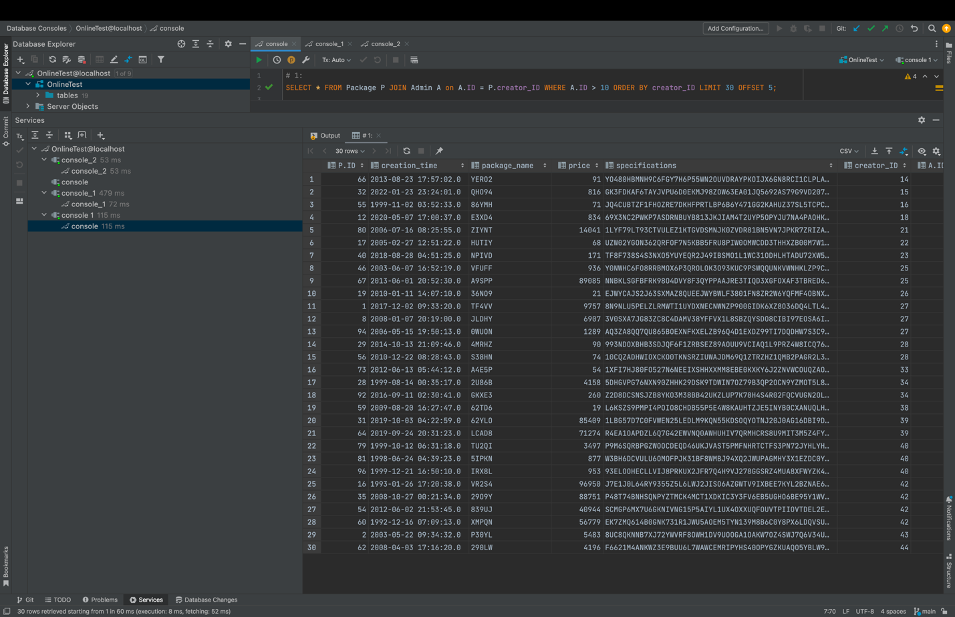

1. Min and max grade from test attempt with responders created by ids > 55, aggregated by responder’s creator id.

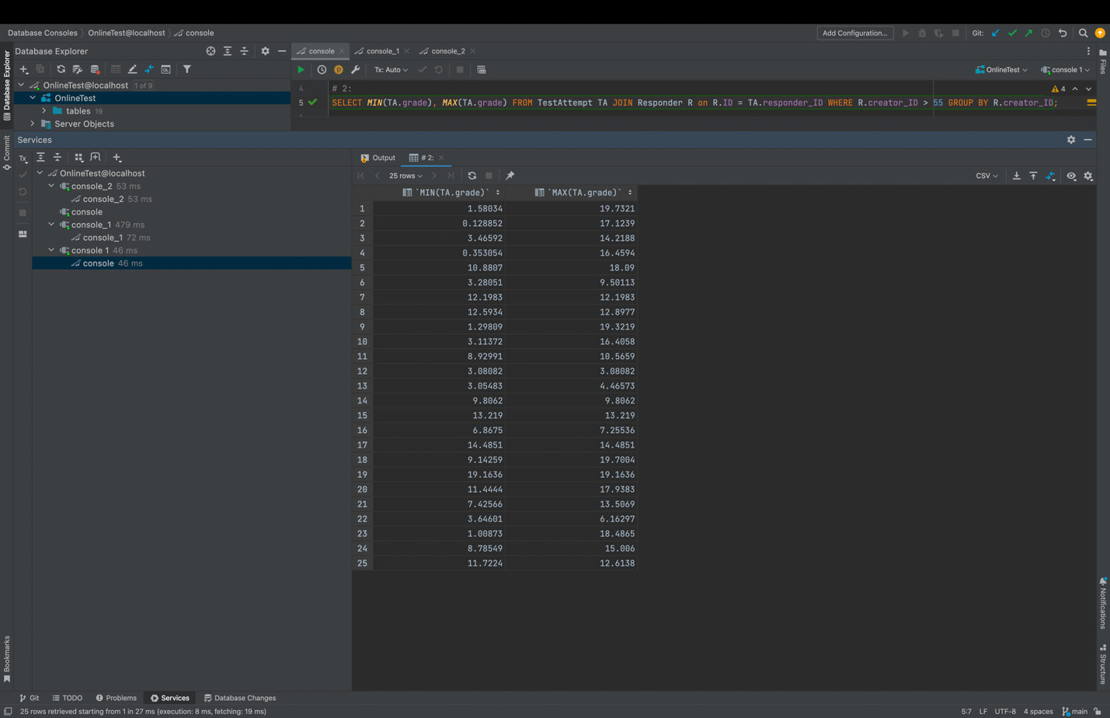

1. avg(salary) of techs created by an admin with at least 1 package

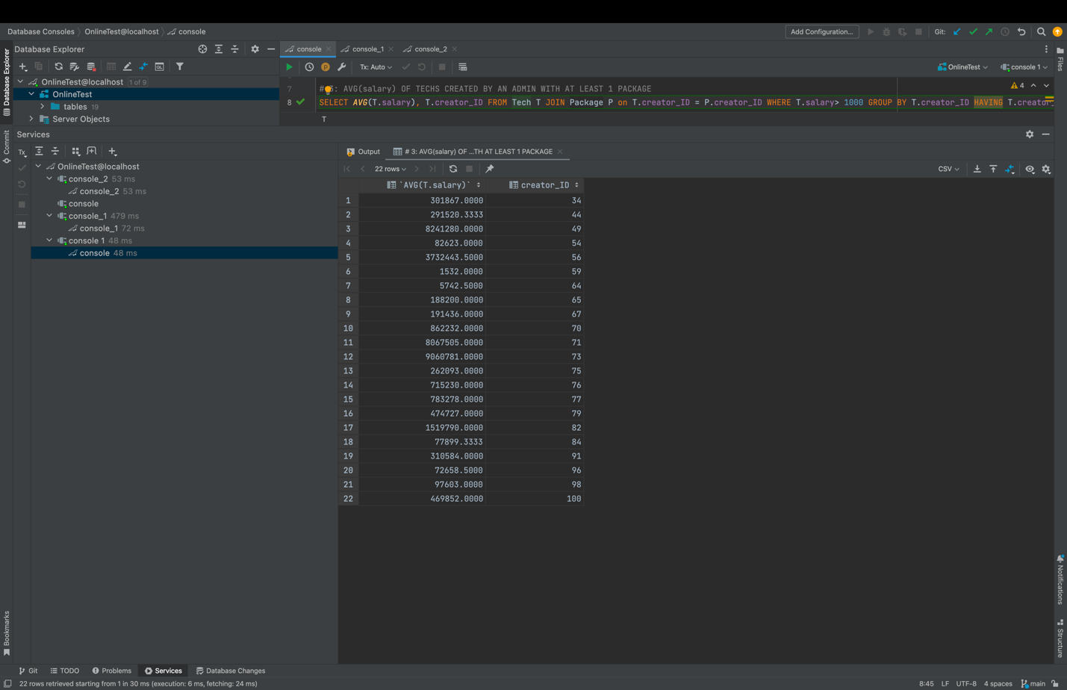

1. The count of WAITING tickets aggregated with their customer id

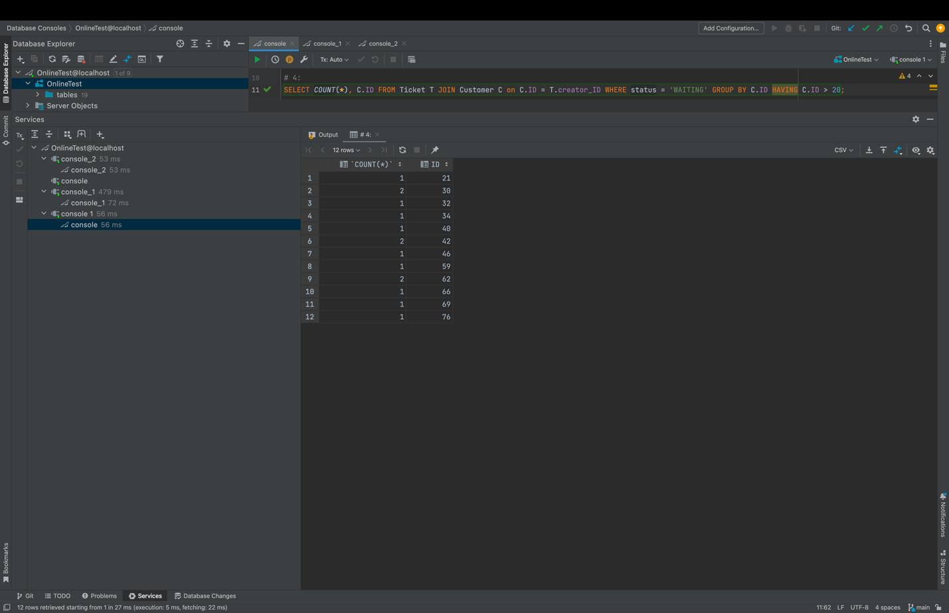

1. The summation of points by responder id = 12 and question creator id > 12

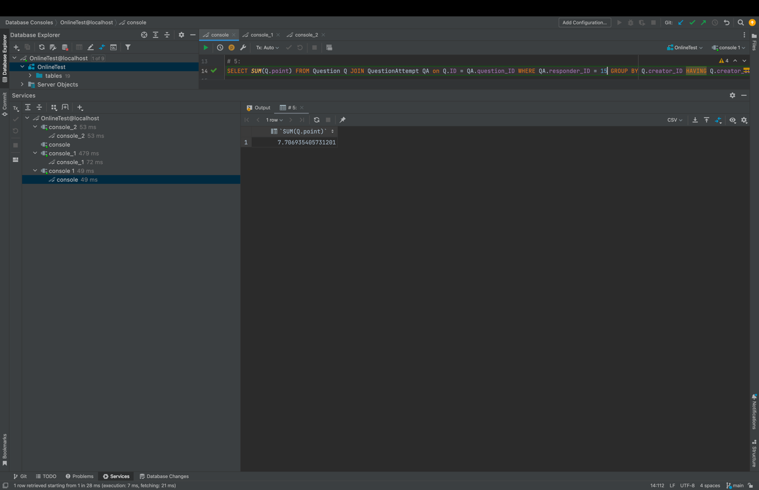

1. The count of courses of the customers having that package

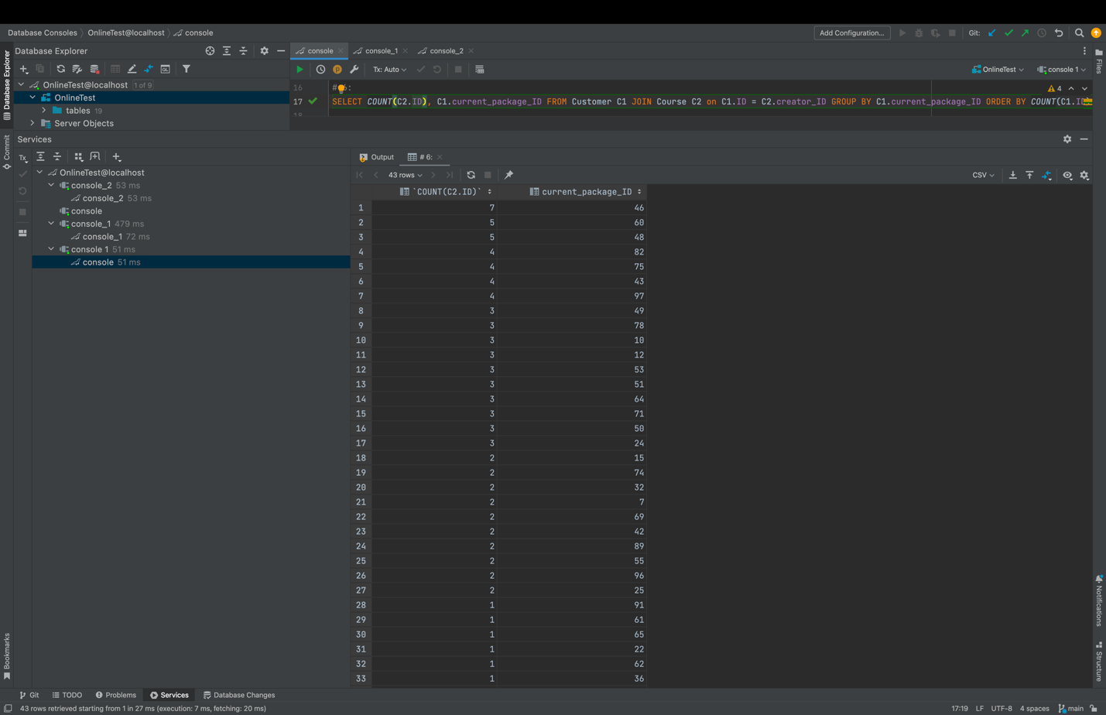

1. AVG of points from question attempt grouped by responders id and question type

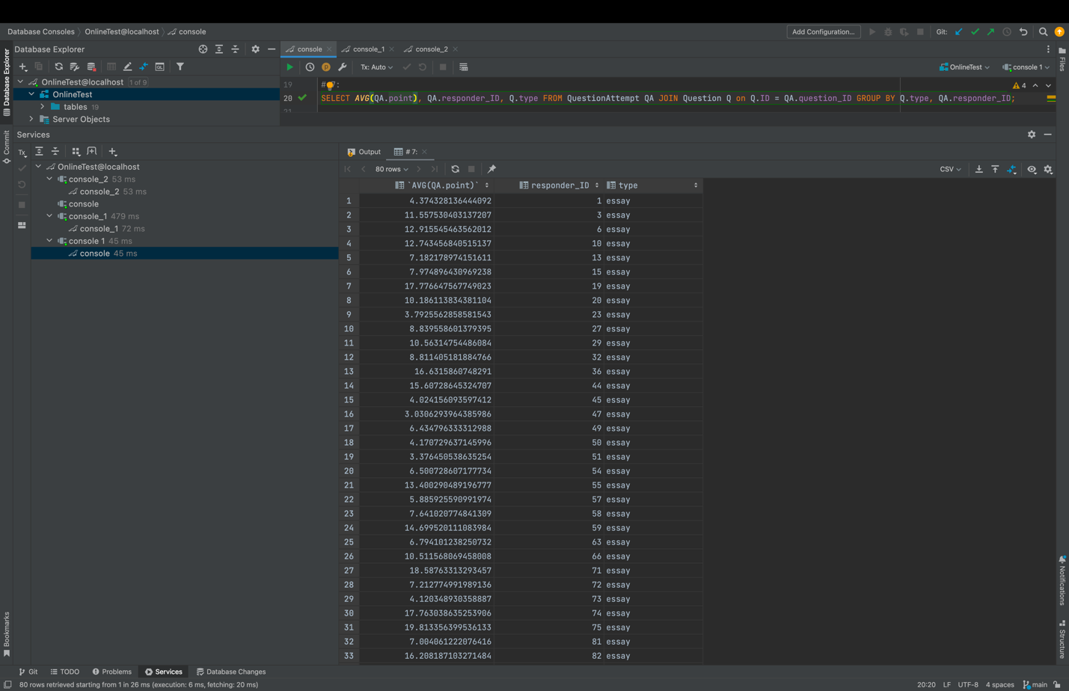

1. The overall salary paid to the support with tickets of status ANSWERED and creator id > 30

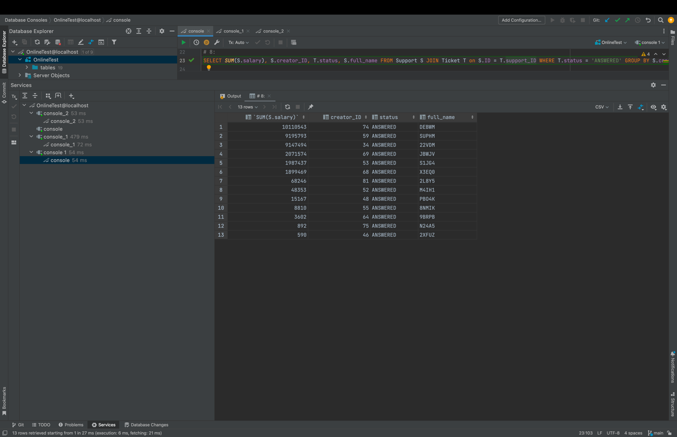

1. The count of each package customers

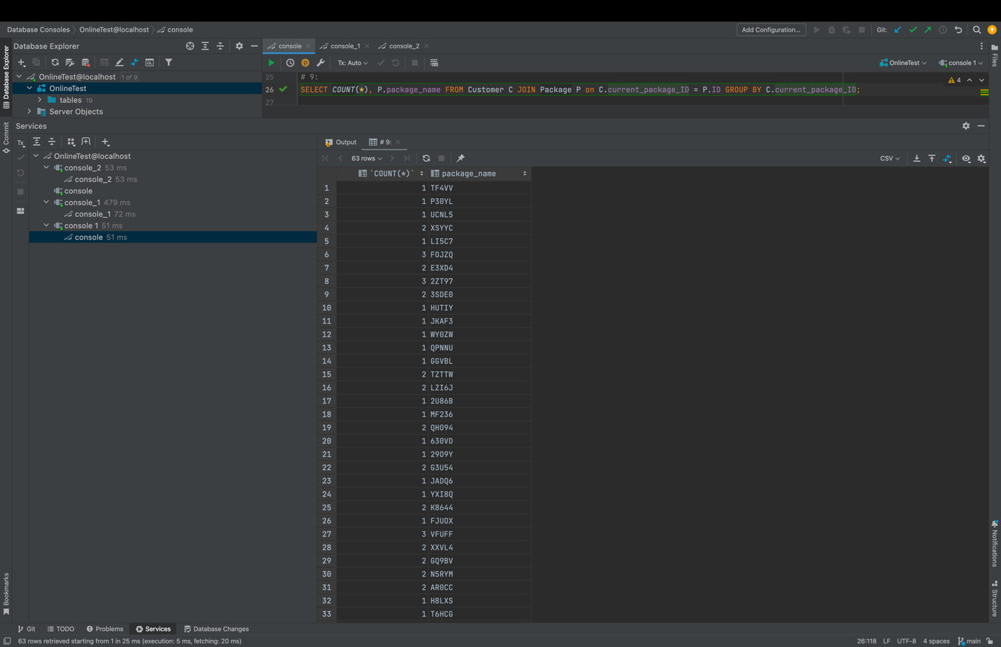

1. The username of a test designer with at least 1 test

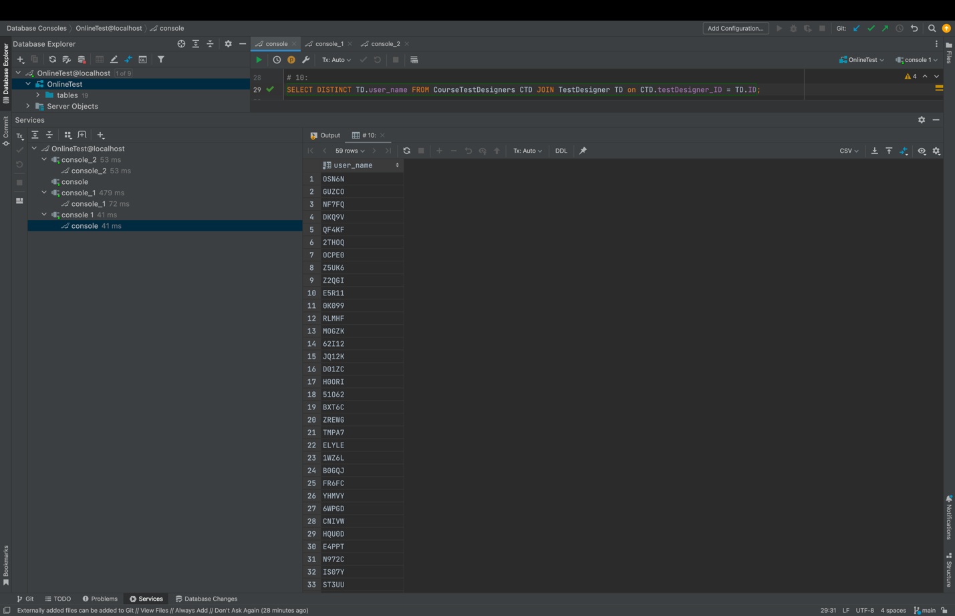

1. To get the support id from ticket refer

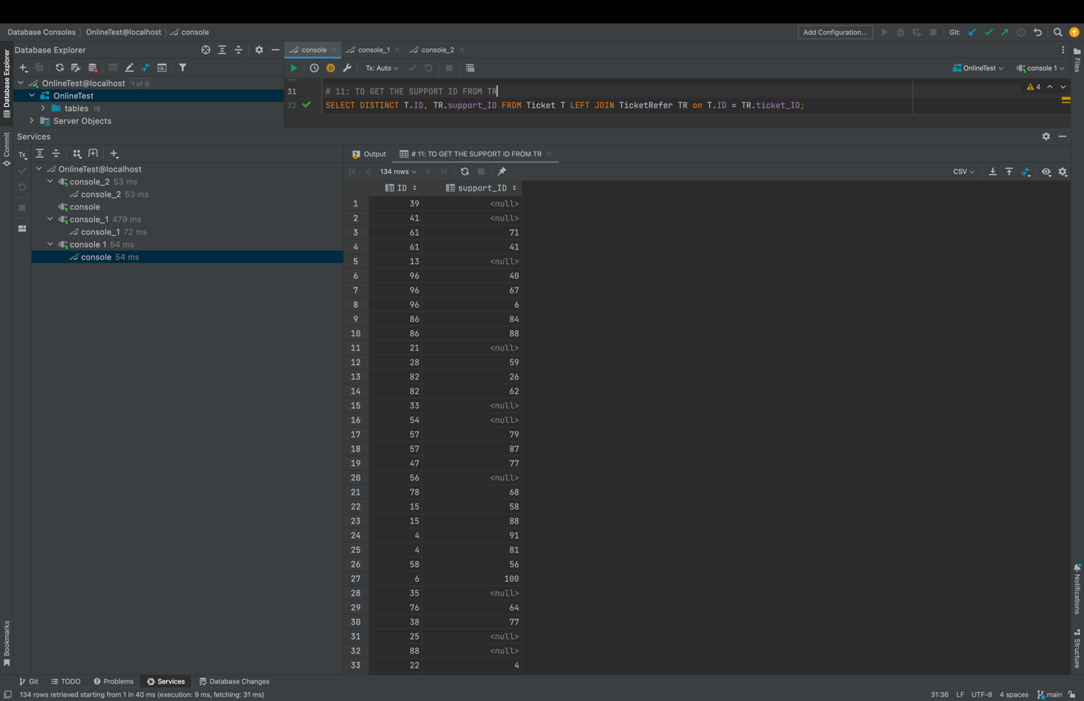

1. To get the course name of each test id

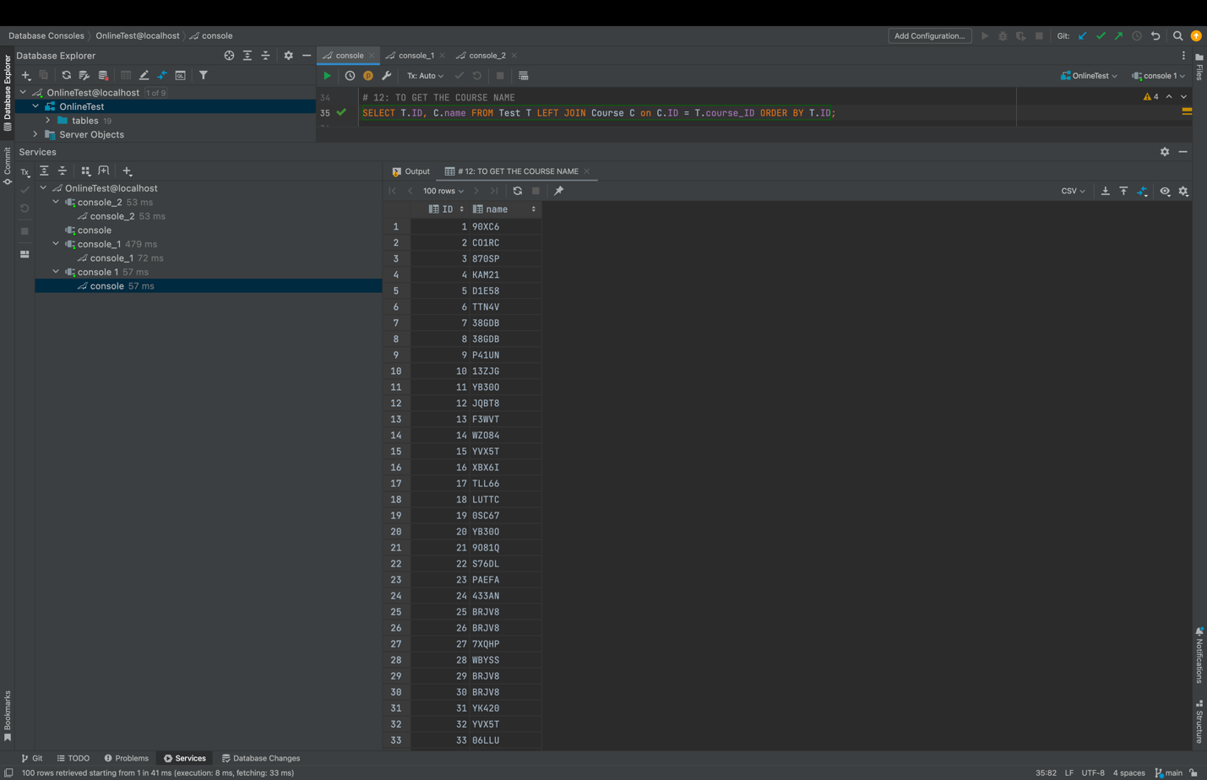

1. To get the never-used questions

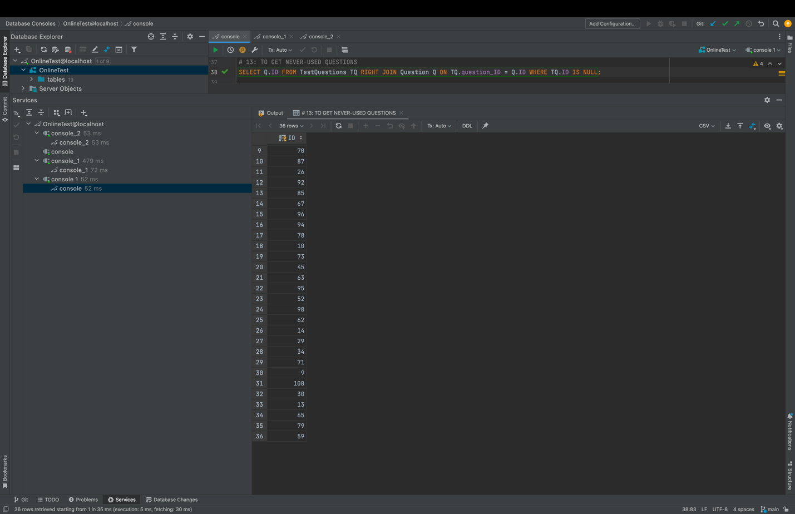

1. To get each test designer of a test, its customer

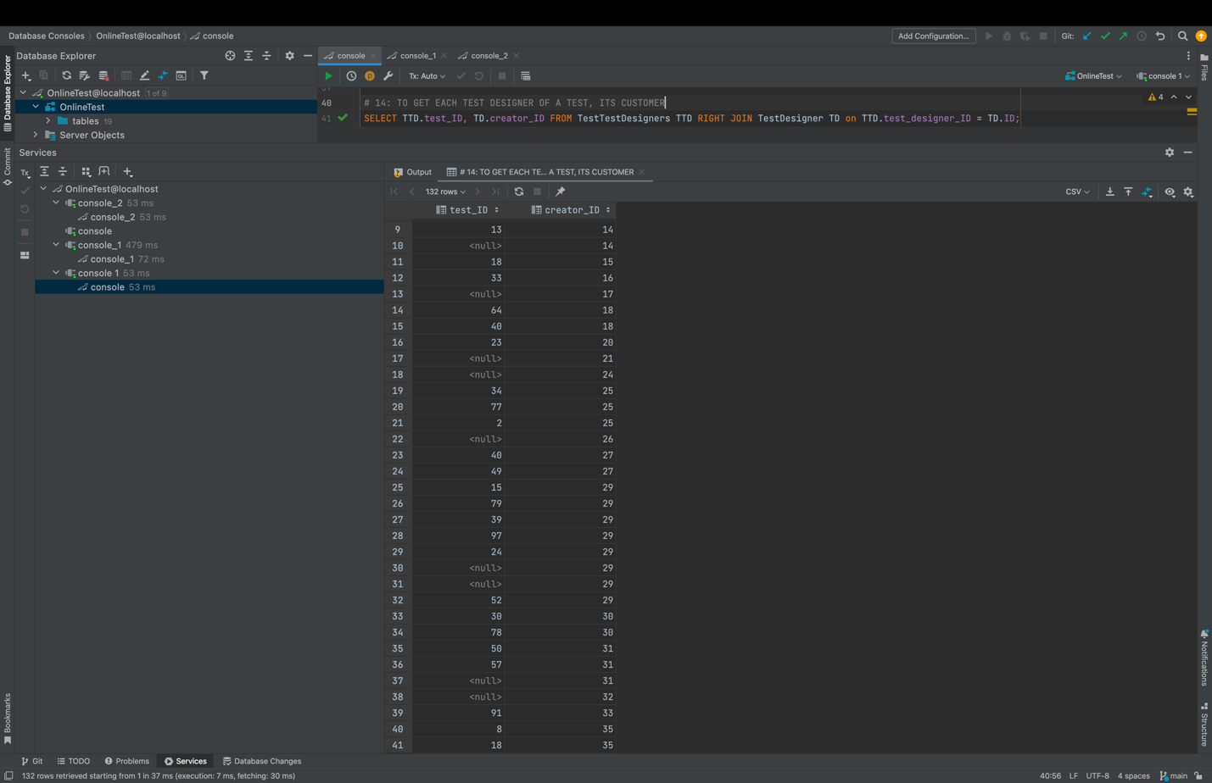

1. To get the corresponding admin name and package id - full outer join

